- In My bookings, in the summary what is this Trace ID? Please remove this if this is not required to be shown on the frontend. Need to show more details. Include Booking ID, Booking Date, Hotel Name, City, Check in, Check Out, Guest Name.(done)
- When I view an online booking:(done all points)
  - Hotel Code, TBO Hotel Code, Hotel Id, City Id is not required.
  - What is this Booking Source in this section? If unnecessary, please remove this.
  - There is “TBO Reference No”, rename it to “Supplier Reference No”
  - In Room details section, there is Room ID, Room index, Room Type Code, Availability Type which I think is not required to display on the frontend.
  - In Guest Section, do not show default Age and Phone Numbers
  - Cancellation Policy in words is showing wrong details than what is mentioned in the Cancellation Slabs. Refer the below screenshot: (done)
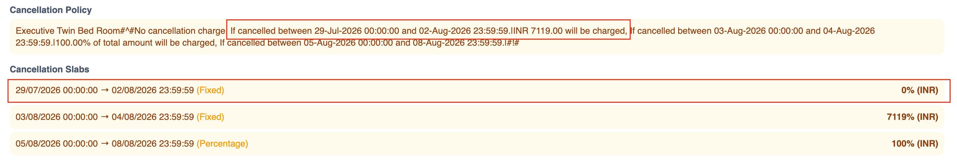
  - Remove the trace ID showing at the bottom of this screen
  - How will someone make payments of the booking which are on Hold?
  - What is this “Agent Commission” in price bifurcation. (done all point)
- For kids we need to use Mastr & Miss in Title dropdown.(done)
- Please float the section “Booking Summary” on the page where we enter Guest’s names.(done)
- How can admin recharge wallet or points? (done)
- Not getting the option to pay by Payment gateway, It is only giving me option to pay by Wallet when I click the Pay now button on the final step. It should open a popup and ask for “Wallet Payment” or Payment by “Payment Gateway” use a small text “Gateway fees applicable” below Payment Gateway option.(done)
- All popups or drop down should close when clicked outside (eg. Wallet Dropdown and Columns Drop Down in My Bookings) (done)
- Need to make the search bar look better. (done all points)
  - Remove the cross and dropdown icon from all boxes, Country, City and Nationality.
  - In the check in and checkout boxes use today’s check in date and tomorrow’s check out date by default instead of the text “Check-In SelectDate” and “Check-Out SelectDate”
  - From Room and Guests remove the text “Selected rooms, adults & children”
  - Remove the Star Rating section completely.
  - Change 1 ROOMS 2 ADULTS to normal case instead of Uppercase and reduce the font little bit. Write Rooms as “Room(s)” Refer the below screenshot, this looks much cleaner.(done)

Pendings from previous testing:
- There is an email going to admin@taworld.com I am getting regular failures. This is not the correct email ID and needs to be removed from everywhere in the backend. Correct admin email ID is admin@taworld.co.in (need to discuss) (done)
- Need to strictly avoid duplicate registrations, phone numbers and emails IDs has to be unique(done)
- In Offline Hotels from where this “15 rooms left” is coming in room categories? (comes from backend) Vipul - Need to discuss (done)
- Display the pricing in the offline website in same way we are showing in Online on the Hotel Details page (need to discuss) (done)

